BOEDirect - Hybrid Post configuration implementation plan
Note: This document contains the following bookmark references (Alt-F9) that are used throughout the remaining text. To update this document for the next BC rollout, simply modify the values of these bookmarks, use the Edit|Select all|F9 to update the field values and save/print the results.

MachineNumber (10)
- all of our boxes have some number
MachineName (PRDBC Ref MachineNumber 10)
- the physical, unix, machine name of the new BC box.
MachinePosts (Post 10,11)
- the Posts this BC box will be supporting.
TradeServerName (ProdBC Ref MachineNumber 10)
- the full, trade server name.
XferOrderName (BC Ref MachineNumber 10)
- the full name used to transfer orders (DBLink name)
TPFBasePort (2907)
- the base port (minus last digit) used for TPF connections (orders/quotes)
i.e. for base port of 29030 enter 2903
POAPair (Pair8)
- setContext PROCESS_ARGS value for this HybridTradeServer
HybridTestClass ()
- the Hybrid test class for this cluster

This implementation plan documents the steps necessary to rollout the BC box and classes by post for the BC box.

Prerequisites
- Login Names & ports for Tpf Adapter (Tpf needs to provide support for these names and create queues for these logins).
  - Total Connections = 10 connections per cluster = 10
Connection Name | HGW Ports
TpfMdrServiceConnection  Sbt Name = S10X1  Tpf Name = MDR | 29070
TpfOrderServiceInboundConnection  Sbt Name = S10X1  Tpf Name = ORDERS | 29070
TpfOrderServiceOutboundConnection  Sbt Name = S10X1OUT  Tpf Name = ORDERS | 29070
TpfReportsServiceInboundConnection  Sbt Name = S10X1  Tpf Name = REPORTS | 29070
TpfReportsServiceOutboundConnection  Sbt Name = S10X1OUT  Tpf Name = REPORTS | 29070
TpfTagServiceConnection  Sbt Name = S10X1  Tpf Name = TAGDATA | 29070
TpfHybridQuoteService1Connection  Sbt Name = S10X101  Tpf Name = SBTQTE | 29071
TpfHybridQuoteService2Connection  Sbt Name = S10X102  Tpf Name = SBTQTE | 29072
TpfHybridQuoteService3Connection  Sbt Name = S10X103  Tpf Name = SBTQTE | 29073
TpfLastSaleServiceConnection  Sbt Name = S10X1  Tpf Name = LASTSALE | 29070

- Login names & ports for CtmAdapter
  - Total Connections = 2 connections per cluster = 2
Connection Name | PORTS
CtmOptionsReportsServiceConnection  Sbt Name = SB10SB10  CTM Name = CTMINPUT | 3566
CtmOptionsAcknowledgementsServiceConnection  Sbt Name = SB10SB10  CTM Name = CTMOUTPT | 3566 (only defined once in setContext)

- Routing Group Names for PCS
- Create the following routing group hierarchy
PRDBC Ref MachineNumber 10x1 (also make this sub group of Global)
- Create this group with GROUP_TYPE=10
ProdBC Ref MachineNumber 10 (also make this sub group of PRDBC Ref MachineNumber 10x1)
- Create this group with GROUP_TYPE=2
ProdGlobal.underlyingProducts (already exists)
ProdBC Ref MachineNumber 10.underlyingProducts (also make this sub group of
ProdGlobal.underlyingProducts)
- Create this group with GROUP_TYPE=20
- Run showClasses –byGroup ProdBC Ref MachineNumber 10 and verify if the above groups exist.

- Database links.
HOST | NAMES
PRDBC Ref MachineNumber 10 | BC Ref MachineNumber 10_sbtorder  BC Ref MachineNumber 10_sbtorderhistory  BC Ref MachineNumber 10_sbtorderlegdetail

- Database schema names.
HOST | NAMES
PRDBC Ref MachineNumber 10 | User name = trdsess_10_owner  Pass word = trdsess_10_owner

- CDB should do replication.

- Infra has to create lmb (agent and process include files).
HOST | XML INCLUDE FILES
PRDGC02 | agent.server.process.bc10Ax1.xml  agent.server.lmb.bc10Ax1.xml  agent.server.process.bc10Bx1.xml  agent.server.lmb.bc10Bx1.xml

- Hybrid test class picked and available on RTH session. Needed for GTC order move test.

Assignment strategy
This is the assignment strategy.
Trade Server | Posts Assigned | Description
ProdBC Ref MachineNumber 10  Boxes: PRDBC Ref MachineNumber 10A/B | Post 10,11 | ‘BC Ref MachineNumber 10’ in transferOrders script.

Implementation

Day 1
  - Verify all external system(s) user/connection/login names are present and working
setContext on PRDGC01A/B, MDGC1A/B & PRDBC Ref MachineNumber 10A/B
    - TpfAdapter login names and ports (base_port: 29070)
      - PROCESS_ARGS="${PROCESS_ARGS} -DprefixTpfPorts=29070, 29070, 29070, 29070"
      - PROCESS_ARGS="${PROCESS_ARGS} -DprefixTpfHybridPorts1=29071, 29071, 29071, 29071"
      - PROCESS_ARGS="${PROCESS_ARGS} -DprefixTpfHybridPorts2=29072, 29072, 29072, 29072"
      - PROCESS_ARGS="${PROCESS_ARGS} -DprefixTpfHybridPorts3=29073, 29073, 29073, 29073"
      - PROCESS_ARGS="${PROCESS_ARGS} -DprefixTpfLoginName=SB10${TPF_SUB_CLUSTER_ID}"
      - PROCESS_ARGS="${PROCESS_ARGS} -DprefixTpfHybridLoginName1=SB10${TPF_SUB_CLUSTER_ID}01"
      - PROCESS_ARGS="${PROCESS_ARGS} -DprefixTpfHybridLoginName2=SB10${TPF_SUB_CLUSTER_ID}02"
      - PROCESS_ARGS="${PROCESS_ARGS} -DprefixTpfHybridLoginName3=SB10${TPF_SUB_CLUSTER_ID}03"
    - CtmAdapter login names (machine number: 10)
      - PROCESS_ARGS="${PROCESS_ARGS} -DprefixCtmHybridLoginName=S101S101”
    - POA pair defined for ProdBC Ref MachineNumber 10 (next in the sequence of 10).
      - -DprefixPoaPair=Pair8
    - DBLinks for order transfers
      - BC Ref MachineNumber 10_sbtorder
      - BC Ref MachineNumber 10_sbtorderhistory
      - BC Ref MachineNumber 10_sbtorderlegdetail
    - Database schema (login name & password )
      - DB_USER= trdsess_10_owner
      - DB_PASSWORD= trdsess_10_owner
    - RoutingGroupAssignment_Prod.properties (file)
      - Group, ProdBC10HybridTradeServer1, defined

  - Perform production minor to install/update.
    - PRDBC Ref MachineNumber 10 setContext (see Step 1 above)
    - MDGC 01a setContext ( HYBRID_GROUPS & HYBRID_GROUPS_UNDERLYING )
      - export HYBRID_GROUPS= …, ProdBC Ref MachineNumber 10
      - export HYBRID_GROUPS_UNDERLYING=…, ProdBC Ref MachineNumber 10.underlyingProducts

  - Have QA install release to PRDBC Ref MachineNumber 10.

  - OPS starts new ProdBC Ref MachineNumber 10 as part of next morning startup.

Day 2
      - Move one, Hybrid test class to ProdBC Ref MachineNumber 10.
        - Enter a GTC order for test class, , in the RTH session to help verify the order move process.
        - Change RoutingGroupAssignments.properties file so test class, , is removed from any existing trade server.
        - Then move test class, , to ProdBC Ref MachineNumber 10.
        - Run assignClassesToRoutingGroups (as explained below in the procedure change) to move these products
        - Move and associated orders to the correct clusters, Hybrid.
        - Bring up Tradeengine on PRDBC Ref MachineNumber 10.
        - Verify the orders got moved.

Day 3
- Move one, real class from Post 10,11 to ProdBC Ref MachineNumber 10.
        - Change RoutingGroupAssignments.properties file so real class is removed from any existing trade server.
        - Then move a real class to ProdBC Ref MachineNumber 10.
        - Run assignClassesToRoutingGroups (as explained below in the procedure change) to move these products
        - Move and associated orders to the correct clusters, Hybrid.
        - Bring up Tradeengine on PRDBC Ref MachineNumber 10.
        - Verify the orders got moved.

Day 4
- Move Post(s), Post 10,11, to ProdBC Ref MachineNumber 10.
- Change RoutingGroupAssignment.properties file to move posts as specified in phase 2 assignment strategy table above (to distribute the posts). NOTE: Test classes stay in their current locations.
- Bring up Id and GlobalServer
- Run assignClassesToRoutingGroups (as explained below in the procedure change) to move orders and then assign classes to the correct groups.
- Bring up the whole system and verify all sessions and if orders are moved correctly.

We can bring up the cluster in the evening after End Of Session. If a problem occurs then we will need to withdraw trader offers.

Operator procedure changes

For any new classes that will be converted from RTH to HYBRID the following procedural change occurs.
    - Day before OPS gets notified of the class being moved.
    - Next day morning ops runs thru the ‘PROCEDURES FOR EBOOK TO CBOEdirect HYBRID MIGRATION’, there will be a change in this procedure in the CBOEDirect steps that are executed.

Currently 1st shift run’s the following script for CBOEDirect on prdgc01a
  - transferOrders Ext Hybrid [Class Symbol]
e.g. transferOrders Ext Hybrid HOB

This procedure above has changed where you do NOT have to specify which Hybrid instance to use (will ALWAYS be Hybrid)

Start of day procedure change
There is a procedure update for the step assignClassesToRoutingGroups.
This procedure update affects only the class assignments to hybrid trade servers.
With post configuration for Hybrid we run into a situation where a class moves from one post to another. The section below explains the enhancements made to the script assignClassesToRoutingGroups to allow us to handle such situations.
The following document (\vobs\dte\documents\SBT\Hybrid\new HTS groups and orders.doc)will explain, in detail, the physical steps needed to actually move the classes for the post to the new HybridTradeServer and then move the orders for the classes to the HybridTradeServer.
orders.doc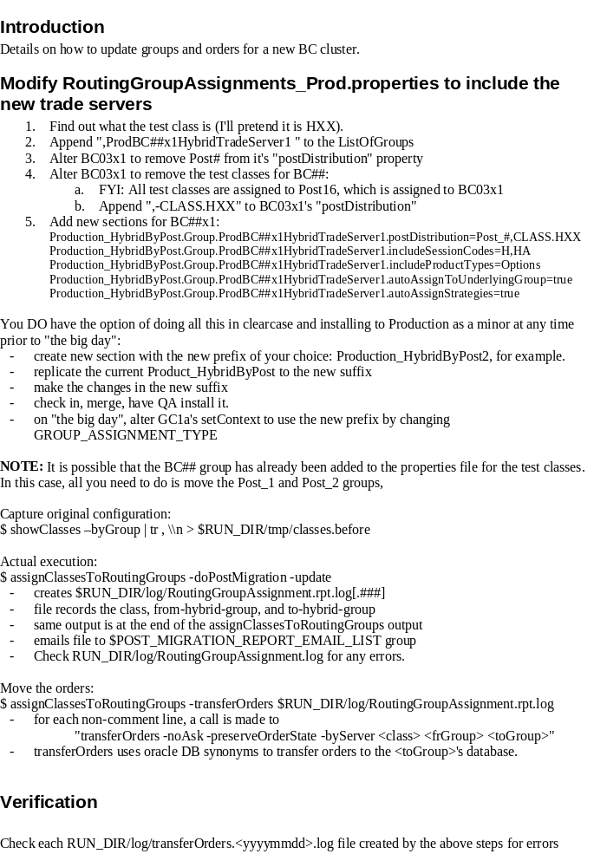
If a class is moving from one post to another. But both the old and new posts are being handled by the same HybridTradeServer then there are no procedural changes.
When a class moves from one post (on one HybridTradeServer) to another post (on another HybridTradeServer), then, we cannot just assign the class to the new HybridTradeServer. This is because all GTC orders and order history also have to be moved along with it.
Hence, you either move the orders and the classes , both at the same time or don’t move the classes to the new post at all.
You can pick either option by passing different arguments to the script assignClassesToRoutingGroups .

Updated procedure for assignClassesToRoutingGroups
- Continue to run the script assignClassesToRoutingGroups –debug -update
- If the script detects that classes will be moved from one HybridTradeServer to another HybridTradeServer, then, in this case by default it will not move the classes and you will see the following message on the screen .
.
POST MIGRATION REPORT: (did NOT execute these migrations)
Class XXX (type=7) from group ‘ProdBC06HybridTradeServer1’ to group ‘ProdBC03x3HybridTradeServer1’
Class YYY (type=7) from group ‘ProdBC06HybridTradeServer1’ to group ‘ProdBC03x2HybridTradeServer1’
See file /sbt/prod/tradeeng/run_dir/log/RoutingGroupAssignment.rpt.log
- At this point you can choose to do nothing about it Or you can choose to move the orders and then MUST run the script again to assign the classes to the correct groups.

If you choose to move orders (at OPS discretion) – or this can be done once a week only (YET to be determined).
- On the primary GC box.
- Run the command assignClassesToRoutingGroups –transferOrders
- This command will use the RoutingGroupAssignment.rpt.log file to move the orders to the appropriate HybridTradeServers.
Verification
- For each class you will see the following message on the screen. You will see a message like this.
================ STARTING SBT ORDERS TRANSFER ================
06/10/03 12:30:02 Starting transferSbtOrdersUsingGlobal symbol IBM from hybrid1_sbtorder to external_sbtorder
06/10/03 12:30:02 Starting transferSbtOrdersUsingGlobal symbol IBM
06/10/03 12:30:02 from hybrid1_sbtorder to external_sbtorder
06/10/03 12:30:02 from hybrid1_sbtorderhistory to external_sbtorderhistory
06/10/03 12:30:02 from hybrid1_sbtorderlegdetail to external_sbtorderlegdetail
06/10/03 12:30:02 Transfering data using - TRADENG1_GLOBAL/TRADENG1_GLOBAL@SBTBD060 ...
06/10/03 12:30:02 Deleting old data in order_transfer_hist table ...
06/10/03 12:30:02 Transferring sbtorder, sbtorderhistory, sbtorderlegdetail ....
------------------- Begin of IBM Summary -------------------
Orders of IBM were transferred from hybrid1_sbtorder to external_sbtorder:
---Success_total=55
---Failed_total=0 → This should always be 0.
---If Failed_total is not zero, check logfile for exceptions or call support.
------------------- End of IBM Summary -------------------

- If there were errors when moving the order’s call support immediately and do not move to the next step.
- If moving of orders is successful then run the command assignClassesToRoutingGroups –debug –update –doPostMigration.
- The above command will now forcefully move the remaining Hybrid classes to the appropriate groups.

